Automated Kubernetes Deployment with CI/CD, Helm, Security & Monitoring

Live URL: http://3.7.34.174
🔹 STEP 0 – Prerequisites (One-Time Setup)
You need the following installed on your local machine or cloud VM:
- git
- docker
- kubectl
- helm
- terraform
- awscli
Accounts required:
- GitHub
- Docker Hub
- AWS (or Azure/GCP – example below uses AWS)

🔹 STEP 1 – Create GitHub Repository
Create a public GitHub repository:
devops-k8s-automated-deployment
Clone it:
git clone https://github.com/<your-username>/devops-k8s-automated-deployment.git
cd devops-k8s-automated-deployment

🔹 STEP 2 – Create the Application (Hello World)
app/index.html
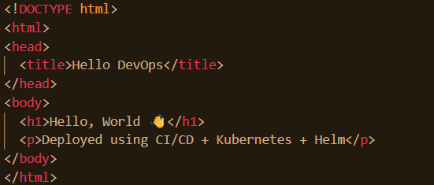

🔹 STEP 3 – Containerize the Application (Docker)
Dockerfile
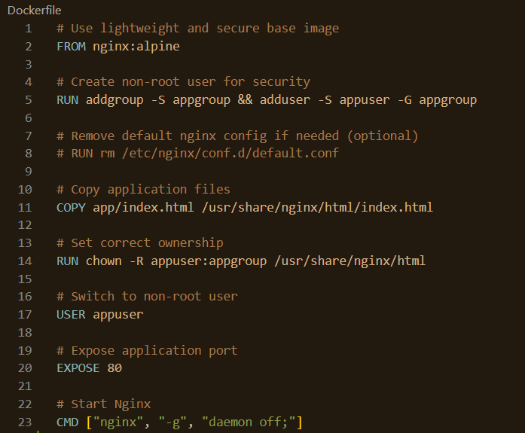
🔹 STEP 4 – Push Image to Docker Hub
Login:
docker login
Build & push:
docker tag hello-app antonyjebinraj/hello-app:latest
docker push antonyjebinraj/hello-app:latest

🔹 STEP 5 – Provision Kubernetes Cluster (Terraform – EKS)
Directory
terraform/
├── main.tf
├── variables.tf
└── outputs.tf
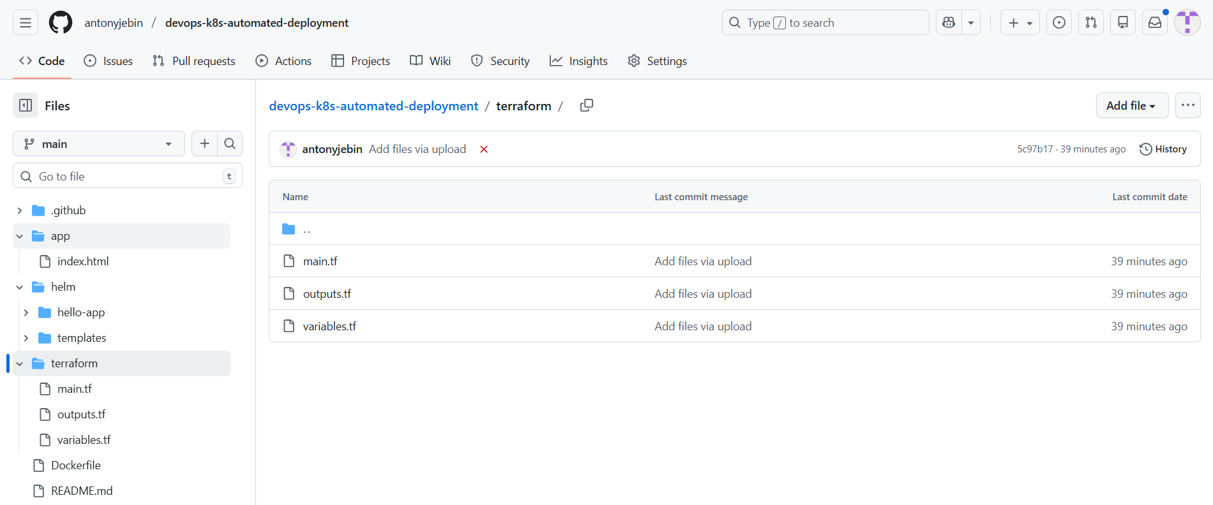
Run:
cd terraform
terraform init
terraform apply
Configure kubeconfig:
aws eks update-kubeconfig --name hello-cluster --region ap-south-1
kubectl get nodes

🔹 STEP 6 – Package Kubernetes Using Helm
Helm Structure
helm/hello-app/
├── Chart.yaml
├── values.yaml
└── templates/
├── deployment.yaml
├── service.yaml
└── secret.yaml
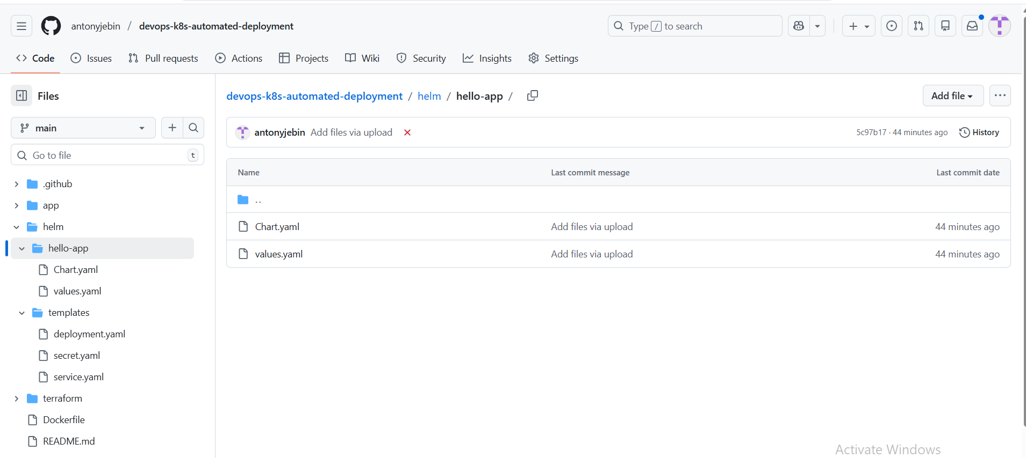

Deploy:
helm upgrade --install hello-app ./helm/hello-app
Get public URL:
kubectl get svc

🔹 STEP 7 – Observability
Install Prometheus + Grafana:
helm repo add prometheus-community https://prometheus-community.github.io/helm-charts
helm repo update
helm install monitoring prometheus-community/kube-prometheus-stack
Access Grafana:
kubectl port-forward svc/monitoring-grafana 3000:80

🔹 STEP 8 – CI/CD Pipeline with Security
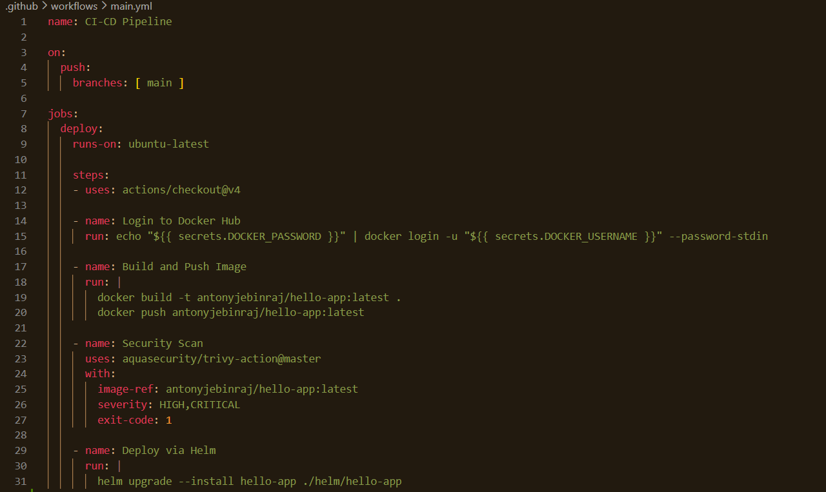
GitHub Secrets
- DOCKER_USERNAME
- DOCKER_PASSWORD
- KUBECONFIG (base64 encoded)

🔹 STEP 9 – Verify End-to-End Flow
- Push code to main
- GitHub Actions runs automatically
- Docker image built & scanned
- Helm deploys to Kubernetes
- App accessible via LoadBalancer URL
✅ This proves full automation

🔹 STEP 10 – Final README (Submission Ready)
Include:
- Architecture overview
- Terraform usage
- CI/CD explanation
- Helm usage
- Monitoring & security
- Live URL: http://3.7.34.174

